1 a.) 3\* .0067 = .0201 Watts

b.) 1100/120=9.16 Amps

c.) 1.2\*2.2=2.64 2.64/9 = .293 hours

2 a.)

5(200)/590=1.695m2

b.) .955\*20=15.47561875 % efficiency 200W \*.1548 = about 31W

c.) Saturn has 14.82 W/m2 5(200)/14.82 = 67.476 m2

3.)

The solar panel farm closest to my home on Google Earth is the Plymouth Public schools Solar Power Plant. The plant is about 250,000 square meters. If the panels have 25% efficiency they would produce 147.5 W per square meter.

147.5 x 250,000 square meters = 36,875,000

36,875,000 / 3600 W = 10,243 families.

This number does seem realistic, a large farm this this one captures a lot of energy from the sun. Weather and time or year does play a role in these numbers as clouds or storms affect the amount of sunlight exposed and ultimately absorbed by the panels. The time of year does as well, as there are less hours of sunlight in the winter than in summer.

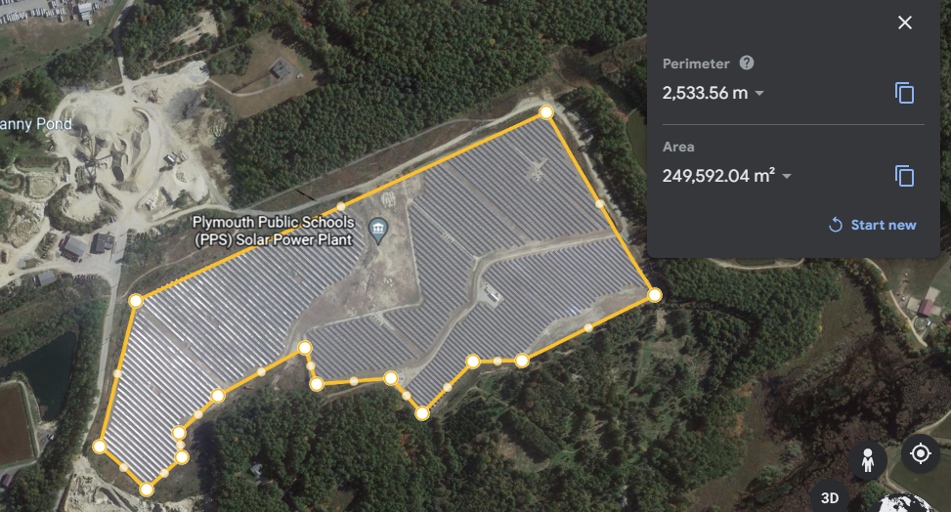

4 a.) 23511.95 MW @ 8/7/2022 18:20

b.) 16066.074 MW @ 8/7/2022 3:25

c.) max on 10/30/22 18:25 13502.796 MW, about 10000 less MW

min on 10/30/2022 12:55 9619.188 MW about 7000 MW less than august

d.) for today, the power draw on the total system is a lot less than what it was on august 7. If I were to guess for what reason, I would say it is because people are using a lot less air conditioning right now than compared to the height of summer. About 6.67 million more ac units are being used at once at the maximum power consumption on august 7 2022 vs October 30, 2022

5 a.) 80ft = 24.384 m

500kV/24.384m = 20.50 kV/m

The breakdown voltage of air is 3000 kV/m

b.) The distance for the wires to arc through dry air would be .1667 m

c.) (86.65)2\*35.266 = 264.65 kW

6.

a.) 94630 x 9.8 x 56.4 = 52303893.6 J

b.) the tank can hold 2534400000 Joules. A gallon of gas weighs 6 lbs so 20 gallons would weigh 120 lbs

120 lbs = 54.43 kg­

c.) as it says on the notes, a lithium-ion battery can carry 875 J/g. 2.5344 x 109 /875 = 2.89646 x 106 grams. 2896.46kg of lithium-ion batteries are required to be equivalent to the capacity of gasoline

d.) Running on gas, the total weight would be 1054.43 kg. (54.43kg/1054.43 kg = 5.16%)

Running on lithium batteries, the total weight would be 3896.46 kg. (2896.46 / 3896.46 = 74.33%)